**EXPERIMENT-20**

**MICROSOFT AZURE**

**Demonstrate Platform as a Service (PaaS) create and configure a new VM Image in any Public Cloud Service Provider.**

STEP-1: GO TO THE CREATE AND SELECT THE AZURE VIRTUAL MACHINE.

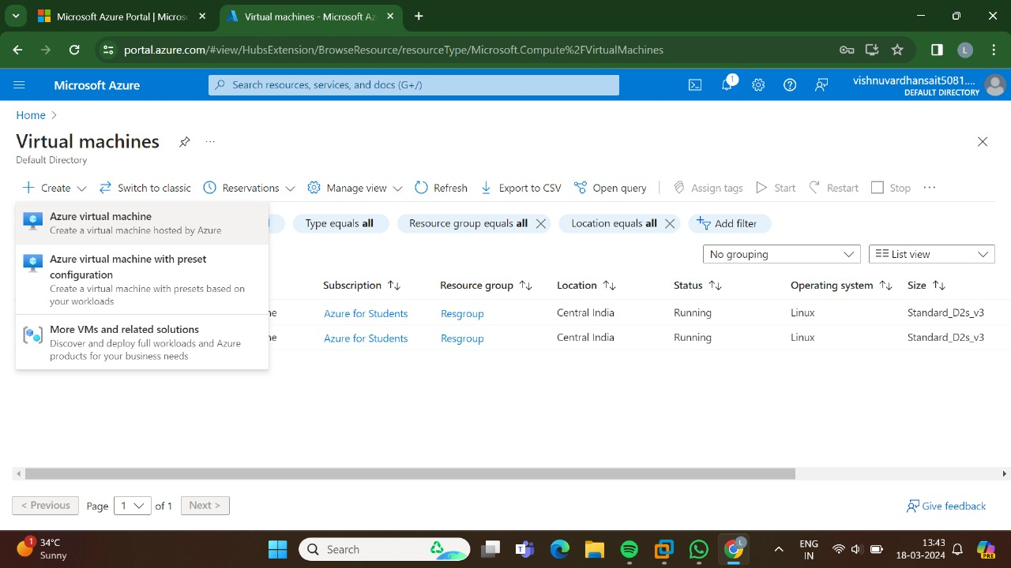

STEP-2:THEN,GO FOR THE BASICS.

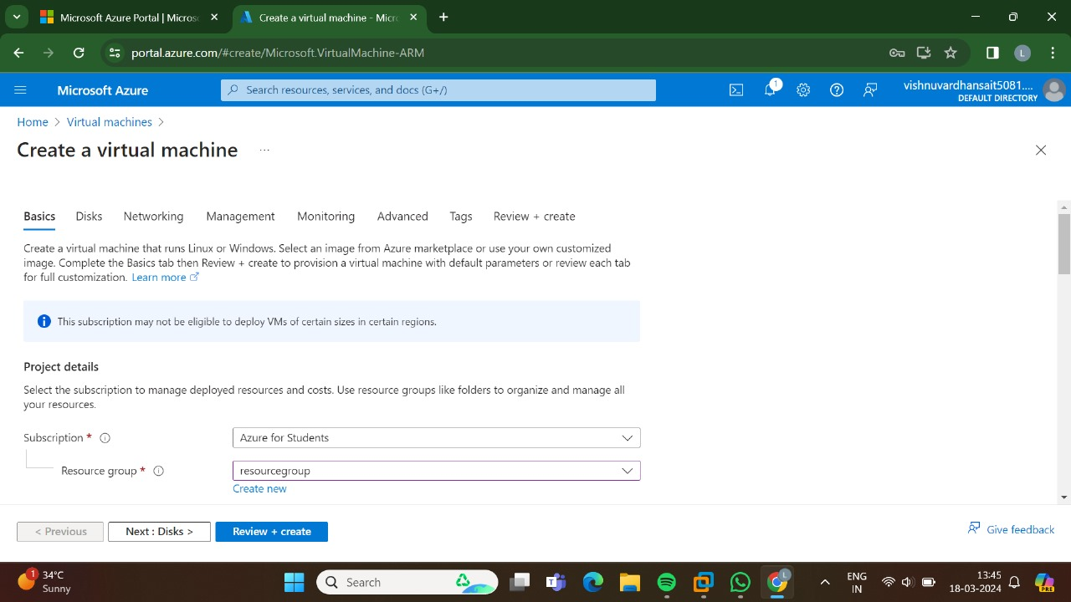

STEP-3:AND, THEN GO FOR THE DISKS.

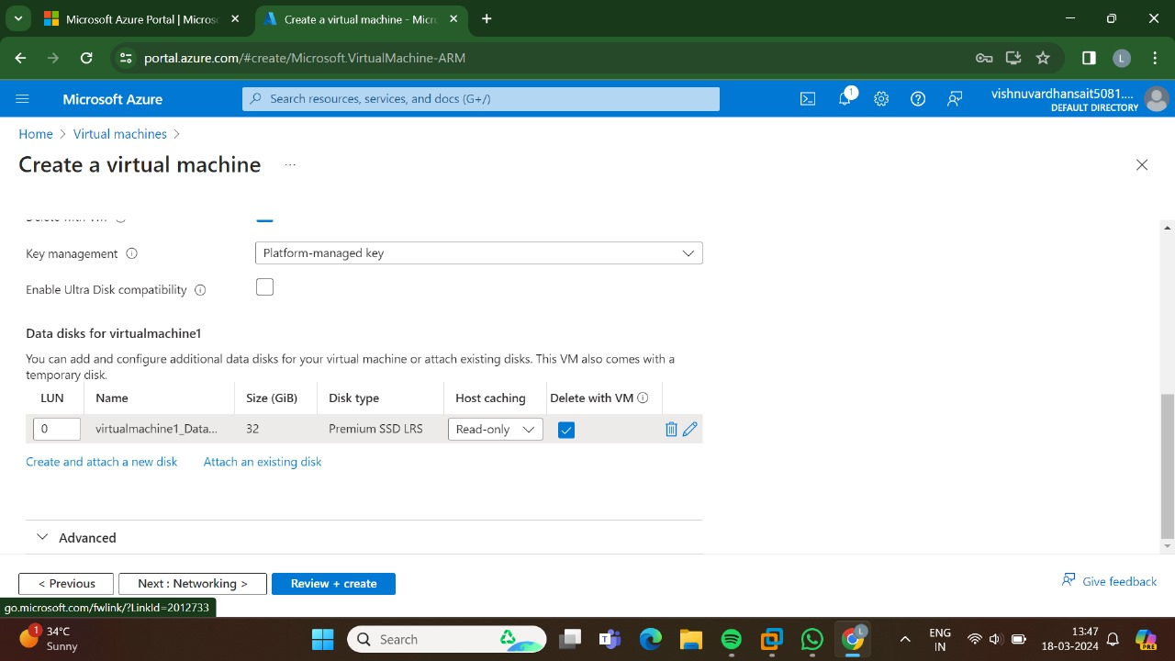

STEP-4:AND THEN GO FOR THE NETWORKING.

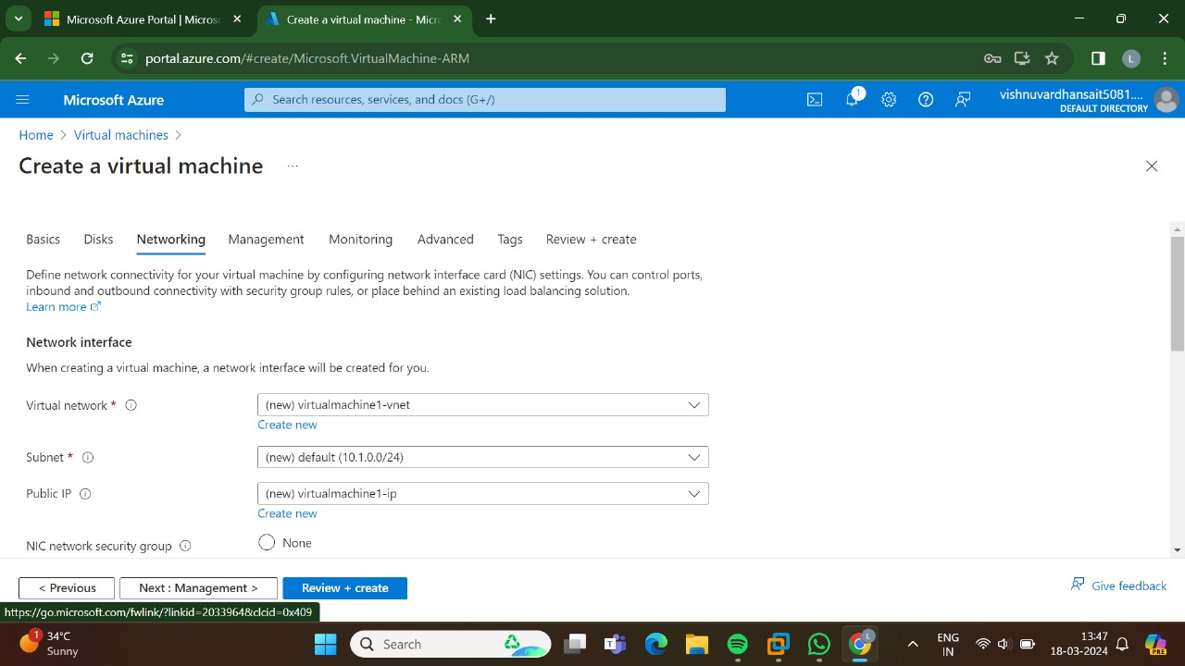

STEP-5:AND, THEN GO FOR THE MANAGEMENT.

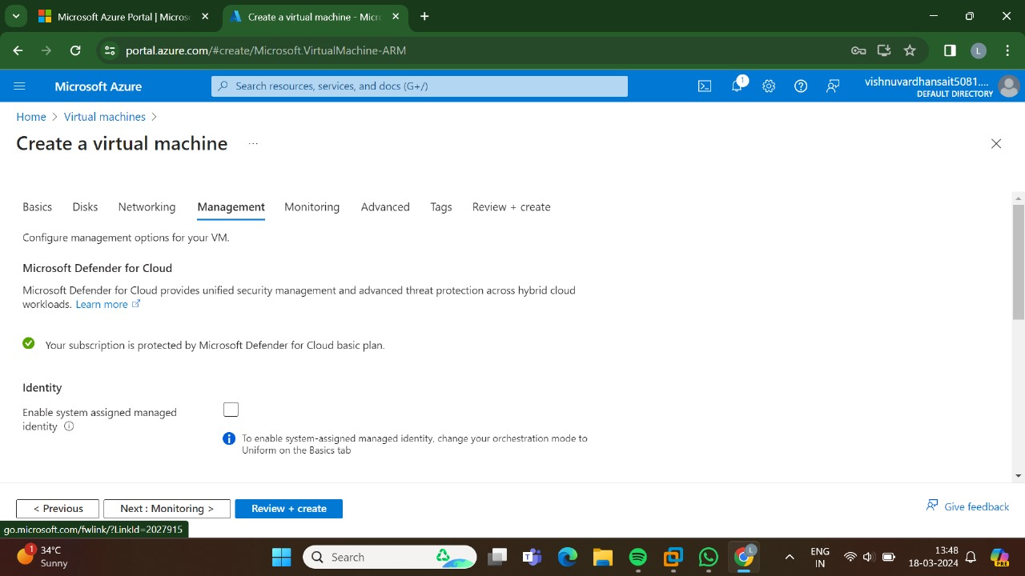

STEP-6: AND, THE GO FOR THE MONITORING.

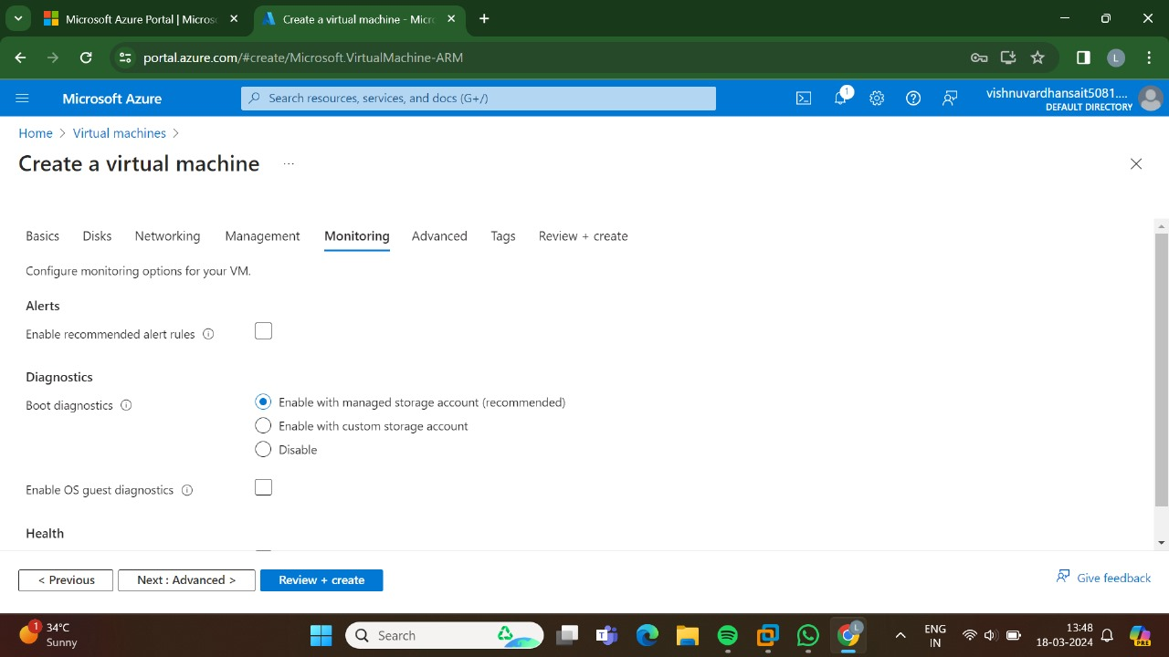

STEP-7: AND THEN GO FOR THE ADVANCED.

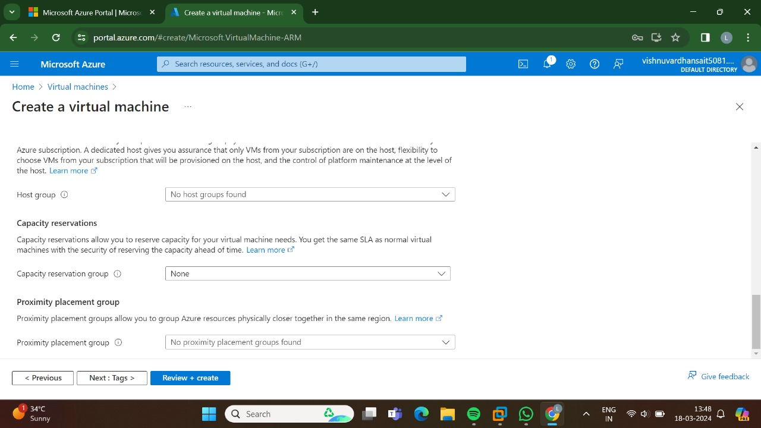

STEP-8: AND,THEN GO FOR THE TAGS.

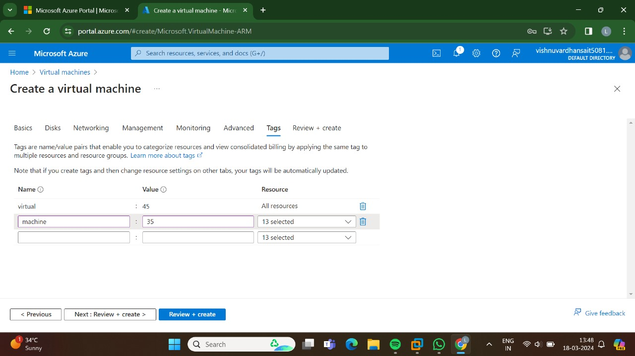

STEP-9: AND, THEN GO FOR THE REVIEW+CREATE AND THEN GO FOR THE CREATE.

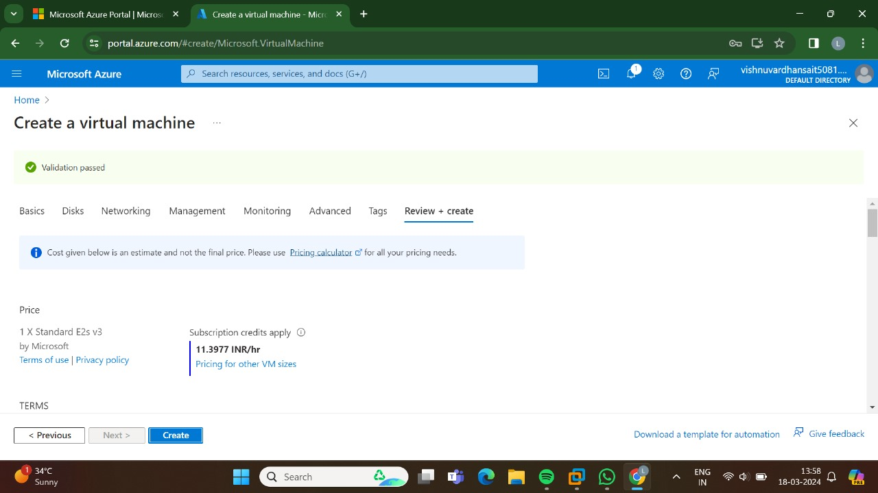

STEP-10:THE, DEPLOYMENT IS INPROGRESS.

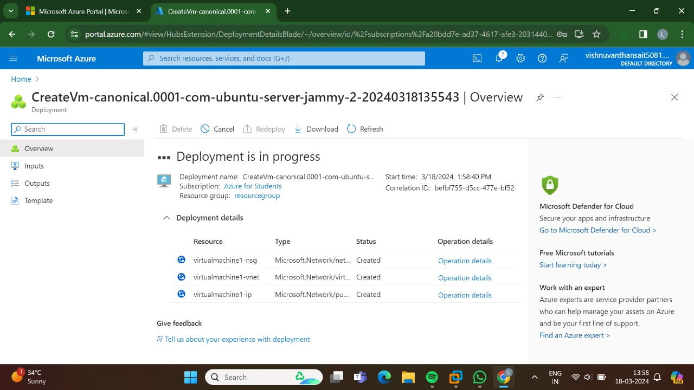

STEP-11:HENCE, THE DEPLOYMENT HAS BEEN COMPLETED SUCCESSFULLY.

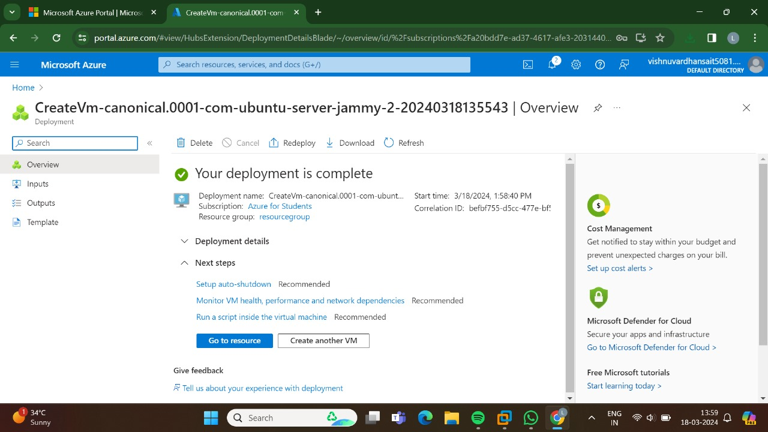

RESULT:THUS ,THE PROGRAM HAS BEEN EXCEUTED SUCCESSFULLY.